**Introduction**

Pollen in the Poaceae is monoporate (having one pore) and annulate (bearing an annulus, or thickened ring around the pore)(Fig. 1a). Under standard light microscopy, the exine (outer surface) of the pollen grain appears psilate (smooth) or nearly so; at Scanning Electron Microscopy (SEM) magnifications, the exine may appear psilate, or spinulose (spined) or scabrate (elements of any shape less than 1µm in any direction) sculpturing may be evident (Zavada, 1983). The pollen wall bears a thick footlayer (blue and purple bands in Fig 1b, c), and is tectate-columellate (Fig 1b,c) (Zavada, 1983). The single pore is generally operculate (having a sexine ectexine structure (Fig 1d right) covering part of the aperture, and which is isolated from the rest of the sexine (Fig. 1d).

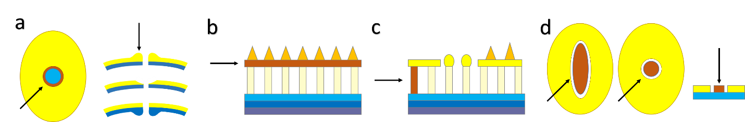

Figure 1: Key structures in a Poaceae pollen grain. In each of the following figures, dark orange highlights the structure being defined. a: Annulus, b: Tectum, c: Columellum, d: Operculum. Sexine shown in yellow in all but b. Cross-section in a right, b, c, and d far right. Polar view in a left and d left and center. Redrawn from Punt et al. (2007)

Intra-exinous channels are often noted in studies of grass pollen micromorphology (Fig 2) (Christensen and Horner, 1974) or visible in Transmission Electron Microscopy (TEM) plates without being mentioned by the authors (c.f., Liu et al., 2004).

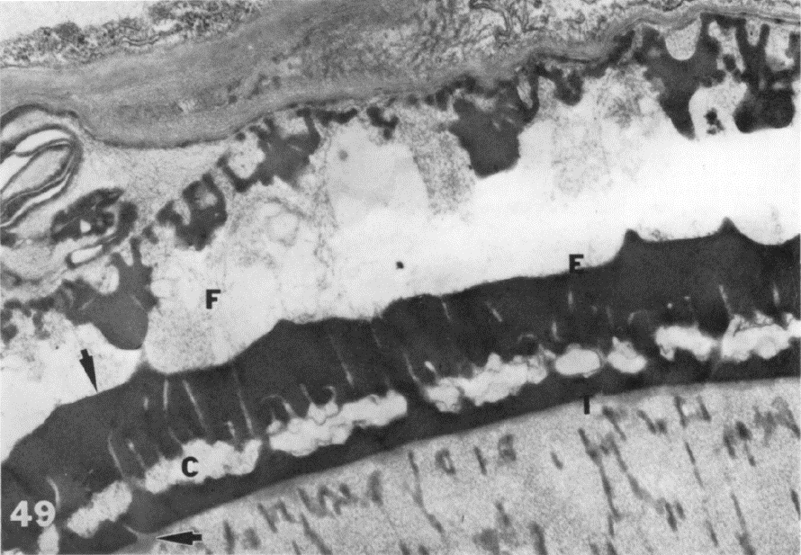

Figure : TEM image of mature grass pollen grain against anther wall. Intra-exinous channels are visible running perpendicular to exine axis (E) and above cavea (C). Image from Christensen and Horner (1974). Used with author permission.

Intra-exinous channels are sometimes listed as a ubiquitous pollen characteristic in the Poaceae (Zavada, 1983; Linder and Ferguson, 1985), and while this appears likely, the claim demands explicit testing. We therefore propose to survey pollen exine structure across the twelve subfamilies of the Poaceae and compare it to the exines in pollen from their close relatives in the Graminid clade: Ecdeiocoleaceae, Joinvilleaceae, and Flagellariaceae using TEM micrographs. Cyperaceae are excluded from this study, even though they also evolved peripheral pollen, as the unique pollen structures in this group are not known or suspected to include intra-exinous channels (see Halbritter et al., (2010)).

The present work will allow us to test the following hypotheses:

H0 Intra-exinous channels are not a valid synapomorphy of the Poaceae

H1 Intra-exinous channels are a synapomorphy of the Poaceae

H0 Intra-exinous channel presence and/or structure is not taxonomically significant at the subfamily level in the Poaceae

H1 The presence and/or structure of intra-exinous channels is taxonomically significant at the subfamily level in the Poaceae, c) Early-diverging lineages do something else

H0 Some or all early-diverging lineages in the graminid clade (Ecdeiocoleaceae, Joinvilleaceae, and Flagellariaceae) produce pollen with intra-exinous channels

H1 None of the early-diverging lineages in the graminid clade (Ecdeiocoleaceae, Joinvilleaceae, and Flagellariaceae) produce pollen with intra-exinous channels

**References**

Christensen, J.E., and H.T. Horner. 1974. Pollen pore development and its spatial orientation during microsporogenesis in the grass *Sorghum bicolor*. *American Journal of Botany* 61: 604–623.

Halbritter, H., M. Weber, and M. Hesse. 2010. Unique aperture stratification in *Carex* (Cyperaceae) pollen. *Grana* 49: 1–11.

Linder, H.P., and I.K. Ferguson. 1985. On the pollen morphology and phylogeny of the Restionales and Poales. *Grana* 24: 65–76.

Liu, Q., N.X. Zhao, and G. Hao. 2004. Pollen morphology of the Chloridoideae (Gramineae). *Grana* 43: 238–248.

Punt, W., P.P. Hoen, S. Blackmore, S. Nilsson, and A. Le Thomas. 2007. Glossary of pollen and spore terminology. *Review of Palaeobotany and Palynology* 143: 1–81.

Zavada, M.S. 1983. Comparative morphology of monocot pollen and evolutionary trends of apertures and wall structures. *The Botanical Review* 49: 331–379.